Turning off Internet Explorers compatibility mode
If you are using Internet Explorer as your web browser, please ensure that compatibility mode is turned off.
To turn off Internet Explorers compatibility mode, do the following:
- Open your Internet Explorer web browser.
- Under the Tools menu heading
  - Ensure there is no check mark next to Compatibility View
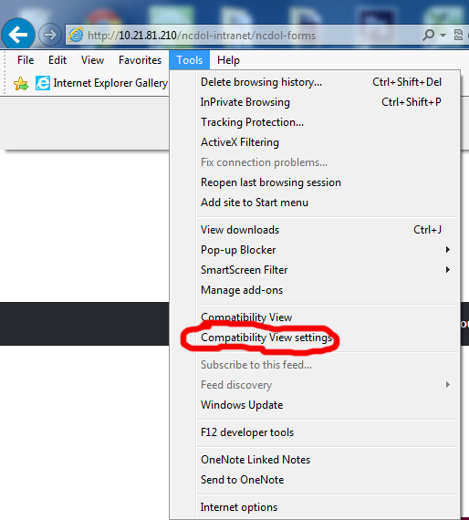
- Next, click the Compatibility View Settings link.
- Ensure all checkboxes are empty. (Image #2)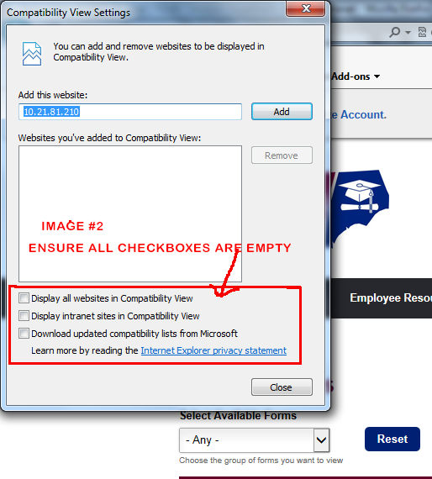
- Click the Close button.
- Your web browser should be optimized.
If you experience any problems, send me an email at dawain.faison@labor.nc.gov or call me at 919-733-2533. Do not call or email the helpdesk .

