Employee Name: |  | Supervisor:
Job Title: |  | Evaluation Date:
Division: |  | Completion Date:
Section/Bureau: |  | Phone:
Gender:  M F | Dominant Hand:  L R B |  | Height (in.):
Glasses or Corrective Lenses: If yes, then what type?
Y N
Date Copy Forwarded to HR: |  | Supervisor/other who performed EEAT :
Working Positions – The Workstation – Optimum Design
1. Head and neck upright or in-line with the torso (not bent down/back).  If "no" refer to Monitor, Chair and Work Area/Work Station Section. |  | Yes | No
2. Head, neck, and trunk to face forward (not twisted).  If "no" refer to Monitor or Chair Section. |  | Yes | No
3. Trunk perpendicular to floor (may lean back into backrest but not forward).  If "no" refer to Chair or Monitor Section. |  | Yes | No
4. Shoulders and upper arms in-line with the torso, generally perpendicular to the floor and relaxed (not elevated or  Stretched forward). If "no" refer to Chair Section. |  | Yes | No
5. Upper arms and elbows close to the body (not extended outward).  If "no" refer to Chair, Work Area/Work Station, Keyboard, and Pointers Section. |  | Yes | No
6. Forearms, wrists, and hands straight and in-line (forearm at about 90 degrees to the upper arm).  If "no" refer to Chair, Keyboard, Pointers Section. |  | Yes | No
7. Wrists and hands straight (not bent up/down or sideways toward the little finger).  If "no" refer to Keyboard, or Pointers Section. |  | Yes | No
8. Thighs parallel to the floor and lower legs perpendicular to floor (thighs may be slightly elevated above knees).  If "no" refer to Chair or Work Area/Work Station Section. |  | Yes | No
9. Feet rest flat on the floor or are supported by a stable footrest.  If "no" refer to Chair, Work Area/Work Station Section. |  | Yes | No
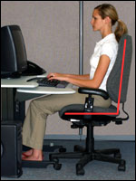 | - Hands, wrists, and forearms are straight, in-line and roughly parallel to the floor.  - Head is level or bent slightly forward, forward facing, and balanced. Generally it is in-line with the torso.  - Shoulders are relaxed and upper arms hang normally at the side of the body.  - Elbows stay in close to the body and are bent between 90 and 120 degrees.  - Feet are fully supported by the floor or a footrest may be used if the desk height is not adjustable.  - Back is fully supported with appropriate lumbar support when sitting vertical or leaning back slightly.  - Thighs and hips are supported by a well-padded seat and generally parallel to the floor.  - Knees are about the same height as the hips with the feet slightly forward.

Working Positions – Seating and Chair Section

10. Backrest provides support for lower back (lumbar area). |  |  | Yes | No
11. Seat width and depth accommodate the specific user (seat pan not too big/small). |  |  | Yes | No
12. Seat front does not press against the back of knees and/or lower legs (seat pan not too long). |  |  | Yes | No
13. Seat has cushioning is rounded with a "waterfall" front (no sharp edge). |  |  | Yes | No
14. Armrests, if used, support both forearms while performing computer tasks and do not interfere with  movement. |  |  | Yes | No
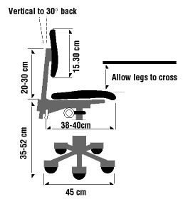 | - The backrest should conform to the natural curvature of the spine, and provide adequate lumbar support  - The seat should be comfortable and allow feet to rest flat on the floor or footrest.  - Armrests, if provided, should be soft, allow shoulders to relax and elbows stay close to the body.  - The chair should have a five-leg base with casters that allow easy movement along the floor. | 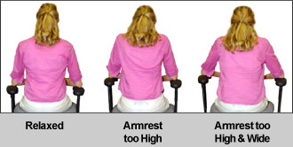
Keyboard and Mouse Section
15. Keyboard/input device platform(s) is stable and large enough to hold a keyboard and an input device. |  |  | Yes | No
16. Input device (mouse or trackball) is located right next to the keyboard so it can be operated without reaching. |  |  | Yes | No
17. Input device is easy to activate and the shape/size fits the hand (not too big/small). |  |  | Yes | No
18. Wrists and hands do not rest on sharp or hard edges. |  |  | Yes | No
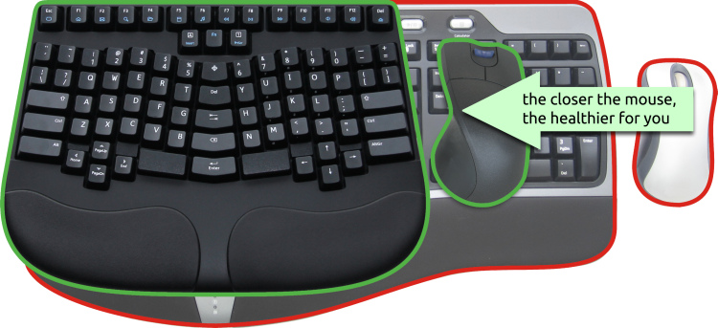 | - Keyboard placed directly in front of worker.  - Shoulders should be relaxed and elbows close to the body.  - Wrists should be straight and in-line with forearms.  - Keep the pointer/mouse close to the keyboard.  - Alternate hand usage when operating the mouse.  - Use keyboard short cuts to reduce extended use.  - Use a wrist rest to maintain straight wrist posture(s) and to minimize contact stress during typing and mouse tasks. | 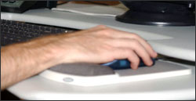
Monitor Section
19. Top of the screen is at or below eye level to be able to read without bending head or neck down/back. |  |  | Yes | No
20. If bifocals/trifocals…able to read screen without bending the head or neck backward. |  |  | Yes | No
21. Monitor distance…able to read the screen without leaning head, neck or trunk forward/backward. |  |  | Yes | No
22. Monitor position…directly in front so not to twist head or neck. |  |  | Yes | No
23. Glare (i.e., from windows, lights) is not reflected on monitor screen…this may cause an awkward posture to clearly  see information on screen. |  |  | Yes | No
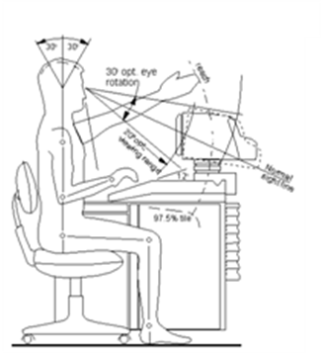 | Place monitor directly in front of worker and at least 20 inches away. May involve work-space re-arrangement.  Place monitor so top line of the screen is at or below eye level. This may involve the raising or lowering of current monitor set up.  Place monitor perpendicular to window or door letting in outside light to avoid glare on the screen. | 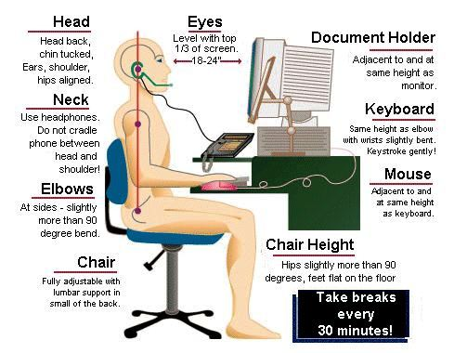
Work Area/Work Station Surface
24. Thighs have sufficient clearance space between the top of the thighs and computer table/keyboard platform (thighs  are not trapped). | Yes | No
25. Legs and feet have sufficient clearance space under the work surface to close distance to the keyboard/input device. | Yes | No

Any Additional Comments: | Intitals
Accessories
26. Document holder, if provided, is stable and large enough to hold documents. |  |  |  |  |  |  |  | Yes | No
27. Document holder, if provided, is placed about same height and distance as the monitor screen, to ensure minimal  head movement, or need to re-focus, when looking from the document to the screen. |  |  |  |  |  |  |  | Yes | No
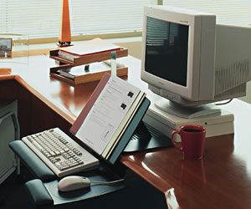 |  | 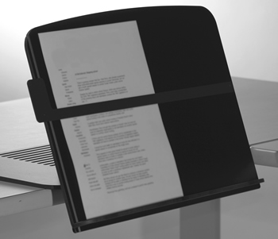 | 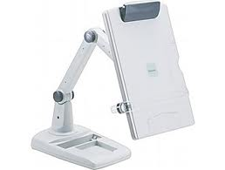 |  |  |  | 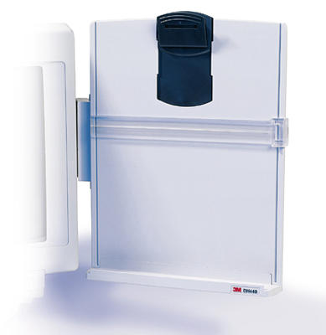
28. Wrist/palm rest, if provided, is padded and free of sharp/square edges that put pressure or push against the wrists. |  |  |  |  |  |  |  | Yes | No
29. Wrist/palm rest, if provided, allows for straight and in-line forearms, wrists, and hands when using keyboard/ input  device. |  |  |  |  |  |  |  | Yes | No
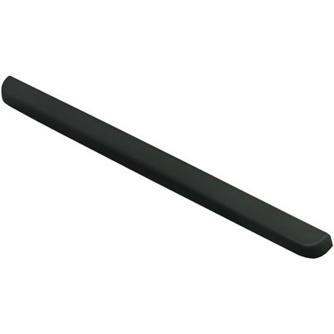 | 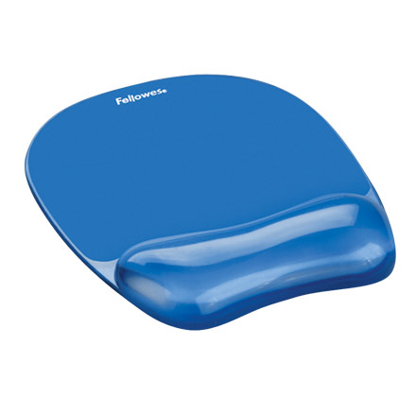 |  |  | 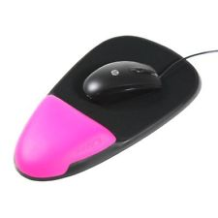 |  | 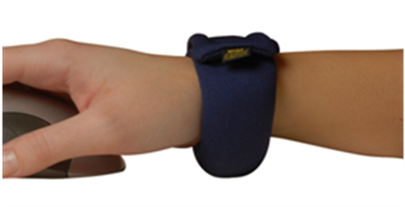
30. Telephone use with head upright (not bent), shoulders relaxed (not elevated) simultaneously with computer tasks. |  |  |  |  |  |  |  | Yes | No
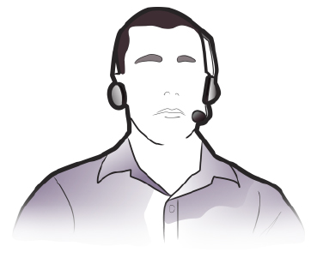 |  |  |  |  | 
31. Workstation and equipment have sufficient adjustability to ensure safe working posture while making the occasional  posture changes. |  |  |  |  |  |  |  | Yes | No
32. Computer workstation, components and accessories maintained in serviceable condition and function properly. |  |  |  |  |  |  |  | Yes | No
33. Computer tasks organized to allow task variations along with other work activities;  Take micro-breaks or recovery pauses while at the computer workstation. (See Deck Stretches document) |  |  |  |  |  |  |  | Yes | No

